Instructions for registering for elective (subjects) courses in the eHMS System (Virtual Dean’s Office)
1) Log into the eHMS System (Virtual Dean’s Office) (https://ehms.sggw.edu.pl).

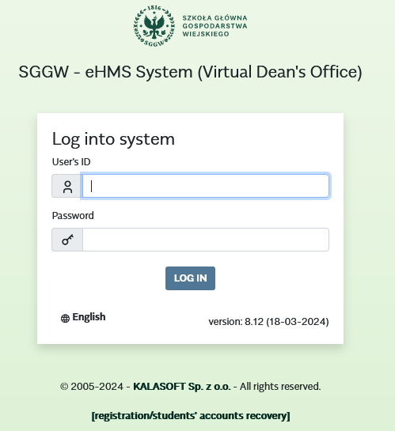
2) Select the tab “MY SCHEDULE”.
3) Choice of offer:
a) From the left-side menu, select “Teaching offers”;
b) In the “CHOICE OF OFFER” window select the academic year and semester;
c) Below the “Go to:” information, click on “Basic schedule offer”.

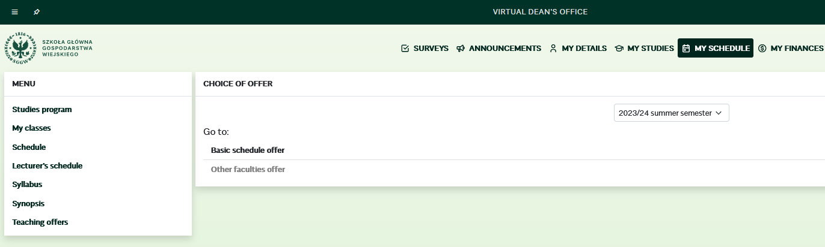
a)
b)
c)

4) In the “Basic schedule offer” window, under the word “Offer”, click on “+” (plus) next to “$PO1-….” in order to display a list of subject to be selected.
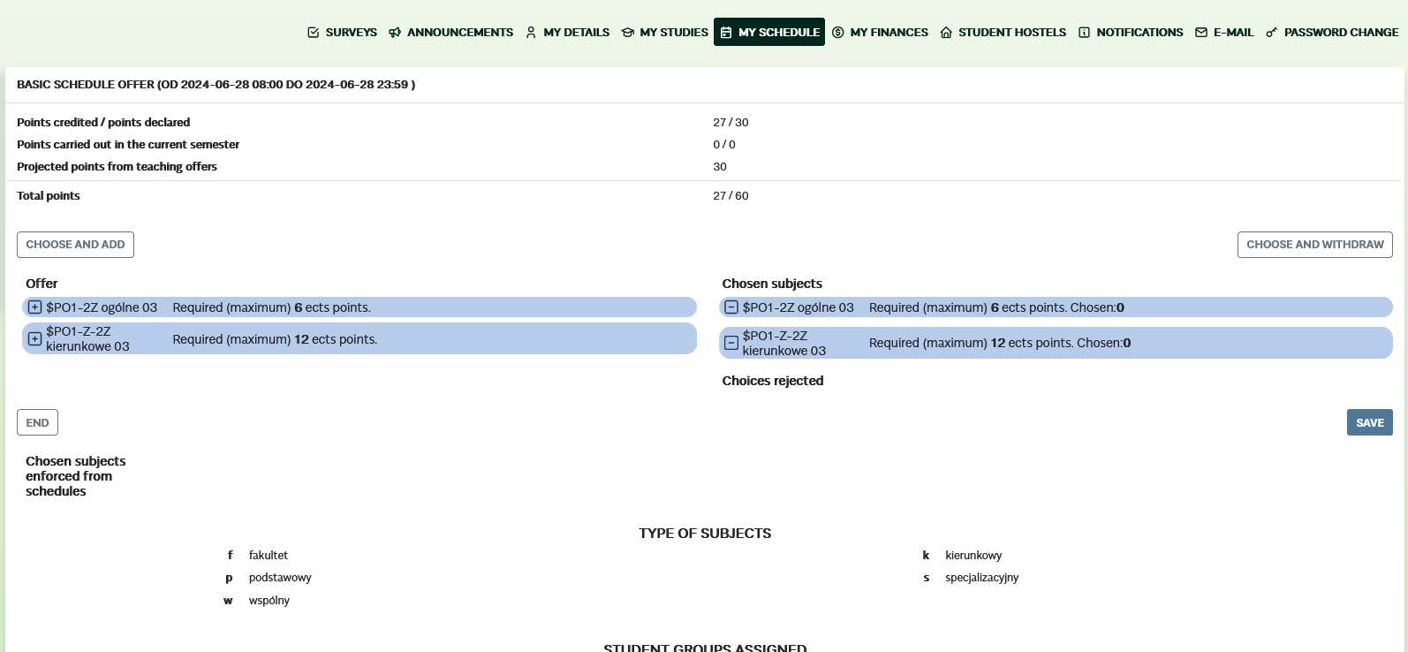
4)
5) From the list of subjects, select the subjects to be implemented:
a) Check the selected language by clicking on the square marked with the “Stud”;
b) Use the button [CHOOSE AND ADD] to navigate to the list of “Chosen subjects”.
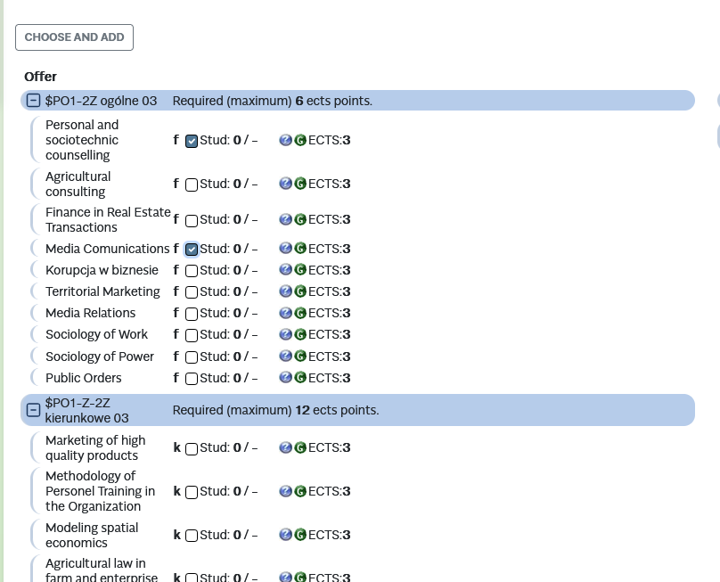
a)
b)
6) Click the [SAVE] button to confirm your selection.
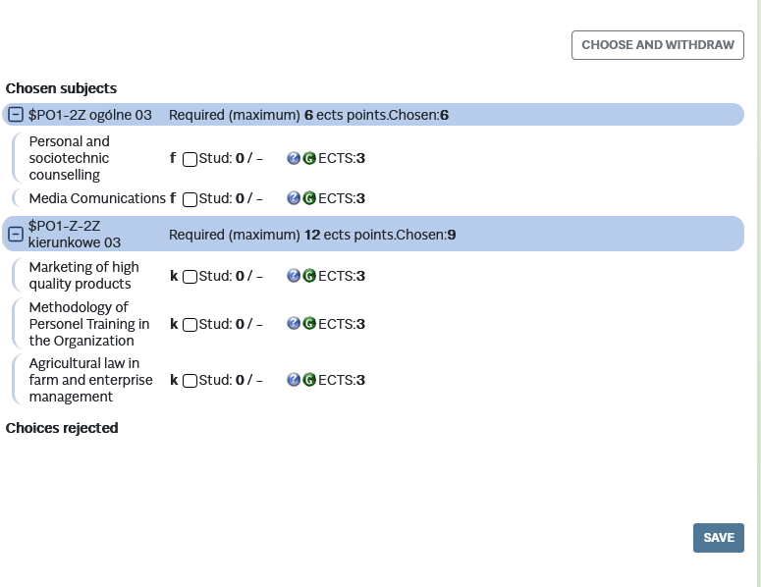
6)

The notification “Changes saved” will appear, confirming the selection of the subject.
Attention: If the selection of subjects is not confirmed, it indicates that you have not completed registration for the subjects (The choices made will not be visible in the system).

